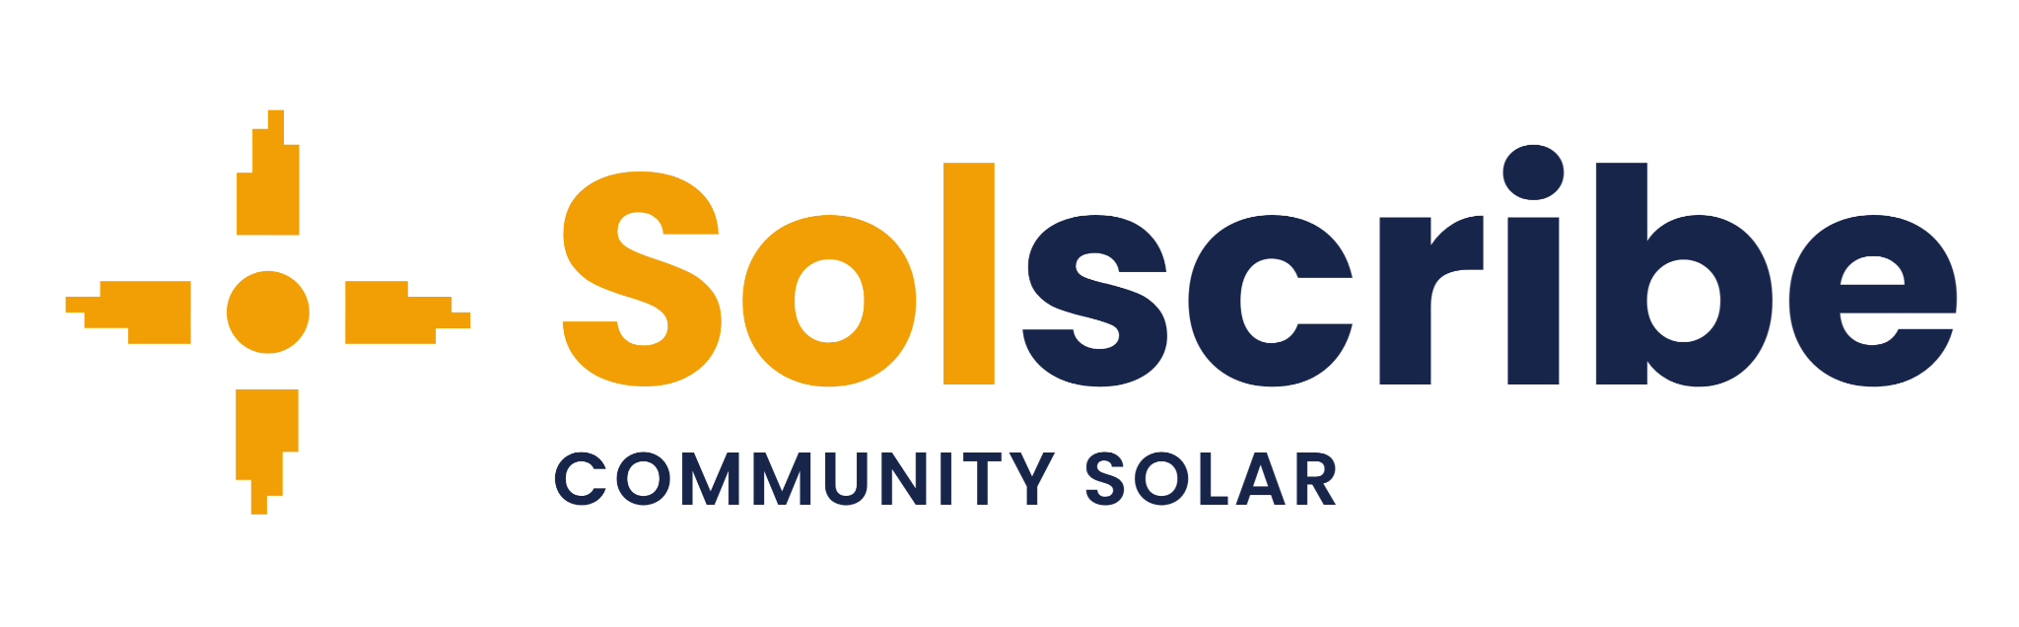
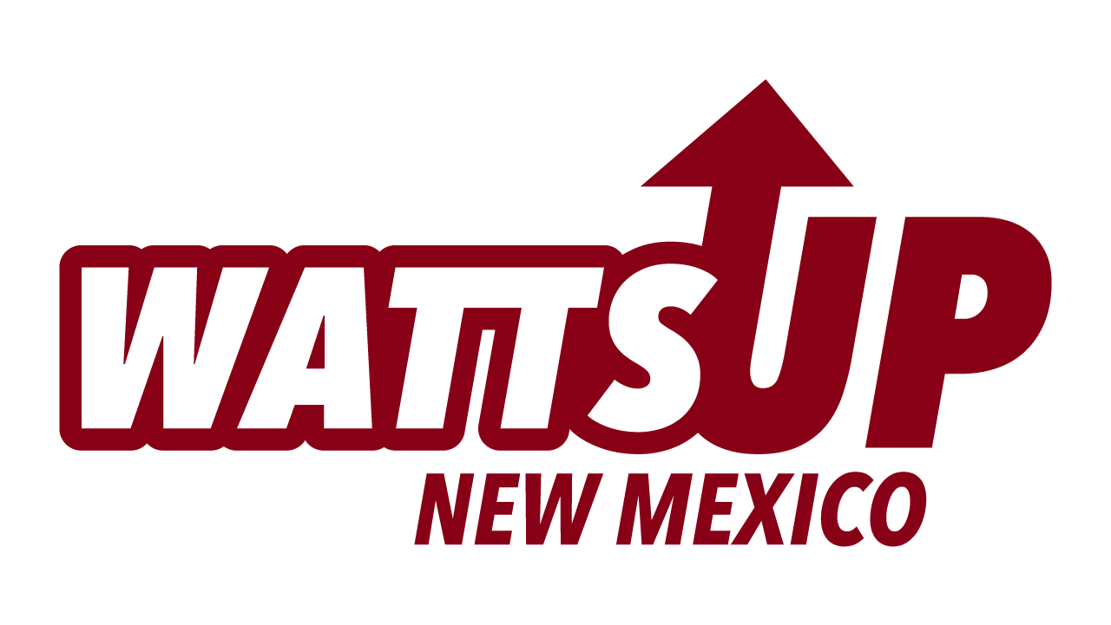

Community Solar Enrollment Specialist

(PNM Service Area - New Mexico)

WattsUp New Mexico is contracted with Affordable Solar to support community solar outreach and enrollment services on Solscribe.

We’re building a local team to help families access New Mexico’s Community Solar Program through projects coming online now, working alongside Affordable Solar, one of the state’s largest and longest-standing solar companies with over 25 years of experience, as additional projects come online over the next several years.

Why This Opportunity Is Different
- Part of the initial team supporting outreach and enrollment for Affordable Solar’s community solar projects on Solscribe
- This is not a 1 to 3 month canvassing gig - it’s a longer-term opportunity tied to a consistent pipeline of in-state projects
- Our most important work is with income-qualified households, while also supporting residential and small commercial customers

Two Ways to Succeed in This Role

Sales-Focused
- Comfortable with door-to-door or direct outreach
- Engage households directly and guide them through a simple enrollment process
- Motivated by performance-based earnings
- Strong communication and closing skills

Community / Marketing-Focused
- Experience with events, outreach, or community organizations
- Participate in community events and tabling at local organizations
- Build relationships and connect people to the program
- Outreach to qualified households through a state-regulated program

Why This Work Matters & Why People Like It
⚡ Help families lower monthly electricity costs
💡 A simple subscription - no equipment, just savings on electricity they already use
🛠️ You’re part of building something local in New Mexico - helping create local jobs
🌱 Support clean energy projects built in New Mexico
📈 Help lower energy costs for families who are hit hardest by rising utility prices
🎓 Gain real experience in sales, outreach, and the state’s growing solar industry

Compensation & Structure
📝 Independent Contractor (1099) Performance-based commission opportunity
💰 Weekly advances against earned commissions may be available for qualified enrollments
💵 Compensation details reviewed during the interview and onboarding
📅 Flexible schedule - part-time or full-time
📈 Consistent performers will build a steady income

Who Thrives Here
✅ Bilingual (Spanish/English) - Preferred for serving our New Mexico communities
✅ People with strong local relationships and a reputation they’re proud to protect
✅ Experience in outreach, community engagement, customer education, and ethical sales


Next Steps
- Learn more about the NM Community Solar Program
- Review wattsupnm.com and our social channels
- Complete the simple contact form at wattsupnm.com/careers
- We’ll follow up quickly to learn if it’s a fit

Compliance: All outreach and enrollment must comply with New Mexico Community Solar Program requirements and applicable consumer-protection standards, and should align with the recommendations outlined in the program’s Consumer Protection Best Practices document. This role may require obtaining any applicable city or town solicitor permits, completing onboarding requirements, and undergoing a background check.

Equal Opportunity: WattsUp NM is committed to providing equal opportunity in both our independent contractor opportunities and in how we serve the communities we work in, without regard to race, color, religion, sex, sexual orientation, gender identity, national origin, age, disability, or veteran status.

We strongly encourage applications from veterans and individuals with deep ties to New Mexico communities, including Native American communities.

Disclosure: WattsUp NM is an independent Channel Partner of Zia CS Services, LLC DBA Solscribe, the Subscriber Organization for Affordable Solar’s community solar projects under the New Mexico Community Solar Program. WattsUp and its contractors are not employed by or endorsed by any government agency or utility.

