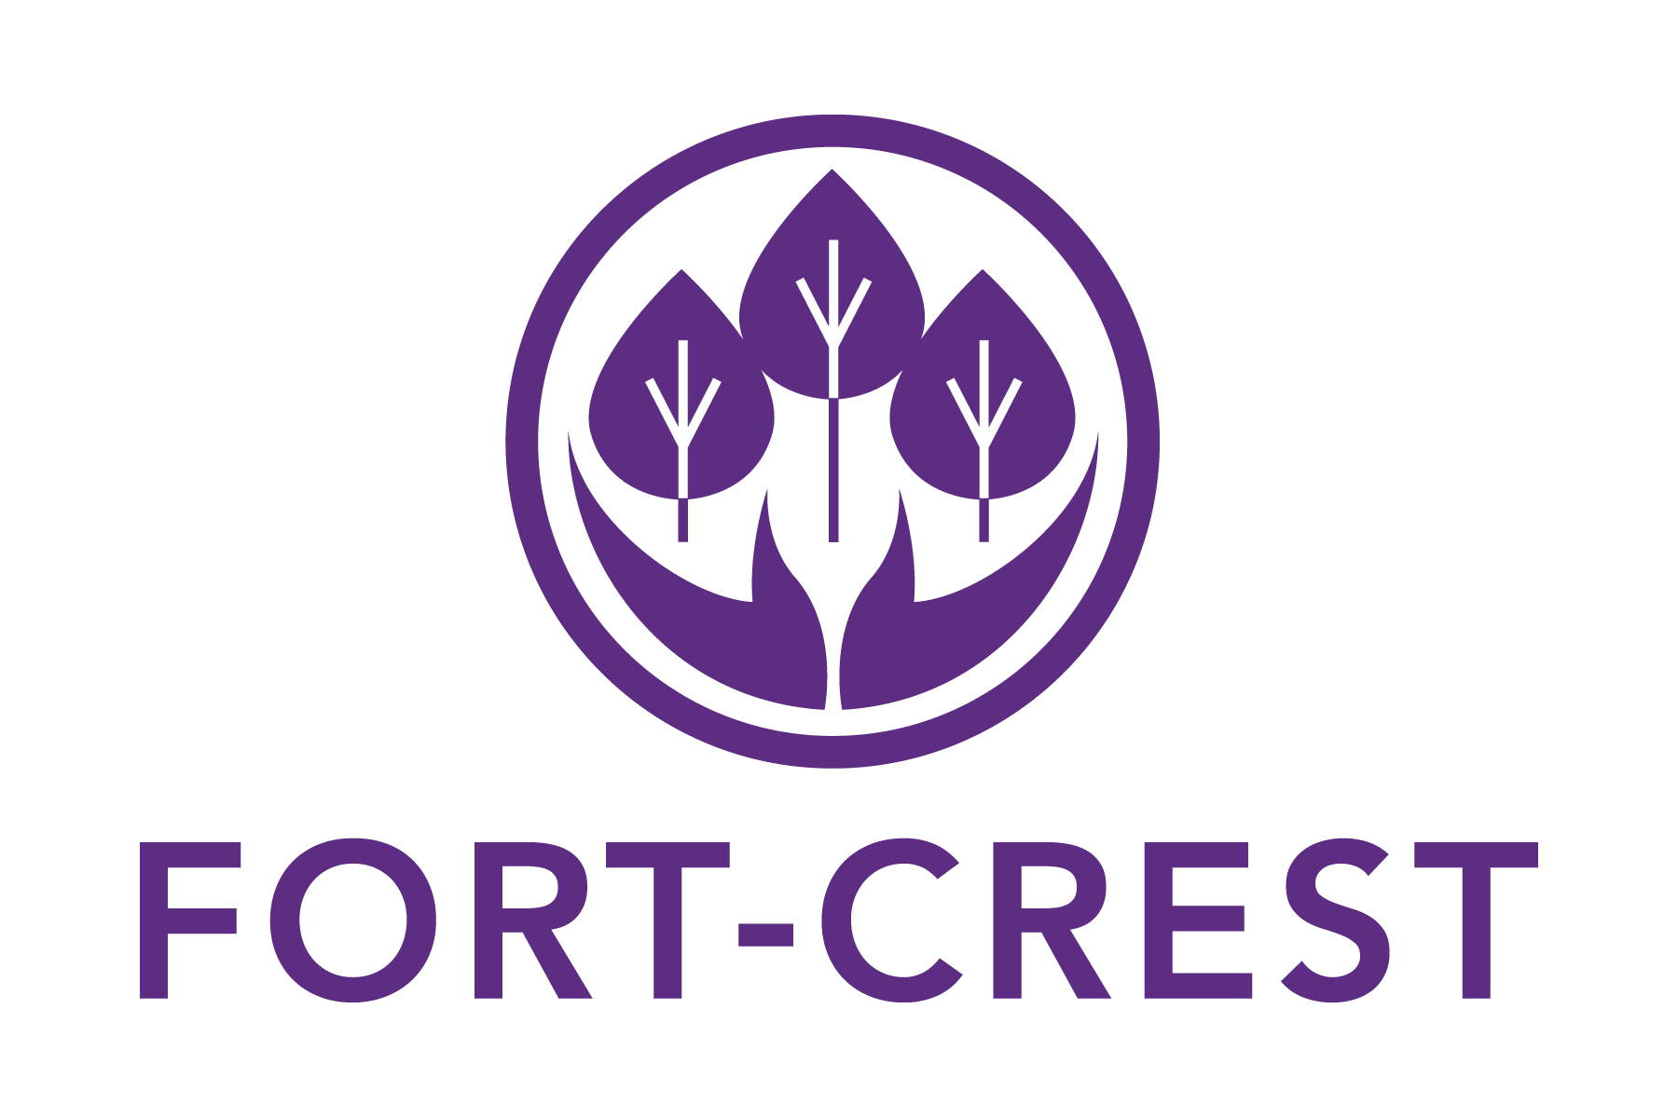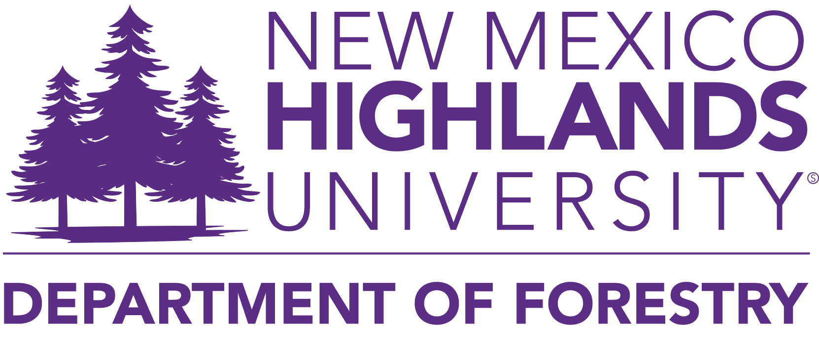

|  |  |
| --- | --- |
|  |  |

**SUMMER RESEARCH AND MENTORSHIP STIPEND STUDENT APPLICATION**

**Summer 2025**

**FORT-CREST PROJECT SUMMARY**

The Forest Restoration Triangle – Centers for Research Excellence in Science and Technology (FORT-CREST) program strives to increase New Mexico Highlands University undergraduate student involvement in professional research, provide research opportunities for graduate students, and facilitate post-university employment as forest managers and researchers, particularly for underrepresented minorities in STEM. The Center will engage students in Science, Technology, Engineering, and Mathematics (STEM) coursework and research with ongoing mentoring and support provided by peers and faculty.

**PROGRAM SUMMARY**

The FORT-CREST program supports undergraduate and graduate students in the Department of Forestry. All FORT-CREST supported students are required to participate in FORT-CREST events, meetings, and mentoring activities. Failure to participate and maintain eligibility requirements will result in a student’s termination from the project.

* **FORT-CREST Research Funding for NMHU Forestry M.S. Students**

For qualified M.S. students in Natural Science with a concentration in Environmental Science & Management whose research relates to forest management and restoration strategies. Selected students will receive one summer of research funding up to $5,000 and will be required to mentor an undergraduate Forestry or Conservation Management student in a project related to their thesis work. Alternatively, students who are unable to find a mentee can attend an event related to forest management and restoration activities. Recipients will also be required to prepare a presentation on the project or experience at events attended during the summer semester.

* **FORT-CREST Mentorship Stipend for NMHU Forestry B.S./B.A. Students**

For qualified B.S. Students in Forestry or B.A. students in Conservation Management who wish to gain knowledge and experience by working with Department of Forestry faculty and M.S. students in their research or attending events, workshops, etc., concerning forest management and restoration strategies. Selected students will receive a stipend of up to $3,000. Students must find a graduate student mentor and complete a project related to the mentor's thesis work. Alternatively, students who cannot find a mentor can attend an event related to forest management and restoration activities. Recipients will also be required to prepare a presentation on the project or experience at events attended during the summer semester.

**DUE DATE AND SUBMISSION**

The submission deadline is Wednesday, May 28th, 2025, by 12:00 PM.

Application Package Includes:

1. Student Application
2. Student Research Summary

Submit digital applications to: Dylin Montoya, Engagement Coordinator, [dylinmontoya@nmhu.edu](mailto:dylinmontoya@nmhu.edu)

**PROGRAM SELECTION & STUDENT INFORMATION**

**QUALIFICATIONS FOR SELECTION**

**M.S. Student Minimum Qualifications and Expectations:**

* Admitted to the M.S. Natural Science program with a concentration in Environmental Science & Management
* Research related to forest management and restoration
* Submit a 1-3 page research summary (details below) or event description
* Letter of recommendation from thesis committee chair
* Preference is given to students who have an undergraduate student mentee
* Registered for at least 1 credit hour in the master’s degree program for Summer 2025
* Must present mentorship project or event experience during NMHU’s STEM Student Showcase (fall 2025) or Annual Research Day (spring 2026)
* Must participate in FORT-CREST activities
* Minimum GPA of 3.0 (copy of transcripts required)

**B.S./B.A. Student Minimum Qualifications and Expectations:**

* Admitted to the B.S. Forestry program or the B.A. Conservation Management program
* Registered for at least 6 credit hours in fall 2025
* Letter of recommendation from a faculty mentor approving the proposed project
* Preference is given to students who have a graduate student mentor
* Proposed project summary (1-2 pages)
* Must present mentorship project or event experience during NMHU’s STEM Student Showcase (fall 2025) or Annual Research Day (spring 2026)
* Must participate in FORT-CREST activities
* Minimum GPA of 2.5 (copy of transcripts required)

**MASTER’S THESIS INFORMATION (Graduate Students Only)**

Check the M.S. in Natural Science program in which you are enrolled.

Environmental Science and Management ____

Name of Faculty Advisor ______________________ Expected Graduation Date (month) _______ (year) 20___

Research funding requested for the summer of (year) ______

Title of Thesis Research ______________________________________________________________________

**Attach a 1-3 page typed research summary** that includes your name, date, research title, research question, location, and methods. Describe how this research relates to forest management and restoration.

**M.S. STUDENT APPLICATION QUESTIONS**

*(Type or print clearly.)*

1. Provide a brief bio describing where you are from and work/school/family experiences that shape who you are.
2. What are your academic and career goals? How do these relate to being in the FORT-CREST project?
3. What strengths do you bring to this program?
4. What obstacles to your success in this program do you face?
5. If you are working with an undergraduate mentee, please include their name, project title, and abstract. Also, describe your role in the project and how it relates to your current thesis work.
6. If you are applying to attend an event such as a conference, workshop, etc., please include the following:

* What is the activity/event and the goal you wish to achieve from it?
* Logistical information on activity/event (location, date and time, etc.)
* Cost (including travel, room and board, etc.)
* Why is this experience useful for you?

**UNDERGRADUATE PROJECT INFORMATION (Undergraduate Students Only)**

Check the program in which you are enrolled.

Forestry ____ Conservation Management ____

Name of Faculty Mentor ______________________ Expected Graduation Date (month) _______ (year) 20___

Research funding requested for the summer of (year) ______

Title of Project ______________________________________________________________________

**Attach a 1-2 page typed project summary** that includes your name, date, project title, project question, location, and methods. Describe how this research relates to forest management and restoration.

**B.S./B.A. STUDENT APPLICATION QUESTIONS**

*(Type or print clearly.)*

1. Provide a brief bio describing where you are from and work/school/family experiences that shape who you are.
2. What are your academic and career goals? How do these relate to being in the FORT-CREST project?
3. What strengths do you bring to this program?
4. What obstacles to your success in this program do you face?
5. If you are working with a graduate mentor, please include their name, research title, and role in your project.
6. If you are applying to attend an event such as a conference, workshop, etc., please include the following:

* What is the activity/event and the goal you wish to achieve from it?
* Logistical information on activity/event (location, date and time, etc.)
* Cost (including travel, room and board, etc.)
* Why is this experience useful for you?