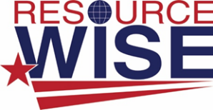

6701 Edith Blvd. NE

Albuquerque, NM 87113

**Job Posting for Office Manager**

**Job Description**

Resource Wise is a small family-owned business, located in Albuquerque, NM. Our company works with water utilities in many areas, from: smart water meter sales and support, meter testing, water conservation audits, water conservation software sales and support, asset management software sales and support, data entry and analytics. If you are enthusiastic about working for a fast-growing company with huge potential, please apply.

The individual will need to be well organized, excellent time management skills, attention to detail, self-motivated, great writing skills, and highly adaptable to perform a wide variety of tasks. Individual will be responsible for the over-all running of the office from taking care of Liability and auto Insurance; banking, answering the phone, bookkeeping, administrative support, and taking care of any issues that come up in a business that contributes to the company’s success. Skills in the following is a must:

* Computer literacy
* Microsoft Office
* Excel
* Quickbooks or Netsuite
* Invoicing
* Accounts Payable and Receivable
* Submitting State Gross Receipts Taxes and employee tax withdrawal
* Submitting Federal Employee Withholding
* Writing reports
* Ordering/Buying office supplies

**Benefits**

After probationary period of 6 months, the following will apply:

* Holiday pay (5 days)
* Five days of vacation or sick leave (1st year)
* Added benefits and vacation days after the first year
* Profit sharing
* Flexible work options
* Career development opportunities
* Starting pay approx. $30,000 to $40,000, depending on education and experience