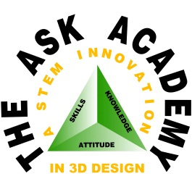
A New Mexico Public Charter School
The ASK Academy
21st Century Design Thinking

Math Teacher (3 positions open)

The ASK Academy (Attitudes, Skills, and Knowledge), a 6th-12th grade charter school in Rio Rancho, New Mexico, is a STEM innovation school with a project-based approach to teaching and learning and has been noted as among the top 10% of high schools in the nation by the U.S. News and World Report two years ago. The 650 scholars follow one of two career pathways—Biomedical Sciences or Engineering and Design. ASK Academy has entered its second decade and is searching for math teachers for both the high school and middle school.

Requirements include: 6-12 teaching license, math endorsement, experience in middle and high school education (preferred), and familiarity with ASK’s STEM focus and project-based learning approach.

The positions are available for the current 2022-2023 school year and the 2023-2024 school year. This is a benefits eligible position. Staff members at The ASK Academy have preference in the school’s student enrollment lottery. Applicants may submit a letter of interest and resume’ electronically to Edward Garcia, CEO at egarcia@theaskacademy.org.

